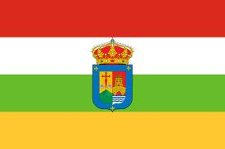

HELLO, WE ARE FROM SPAIN

My Autonomus Community
Is called the Rioja
and is has one provinces.
The capital is Logroño.
The municipality where I live is called
Logroño.In my Autonomus Comunity we
speak one language.

