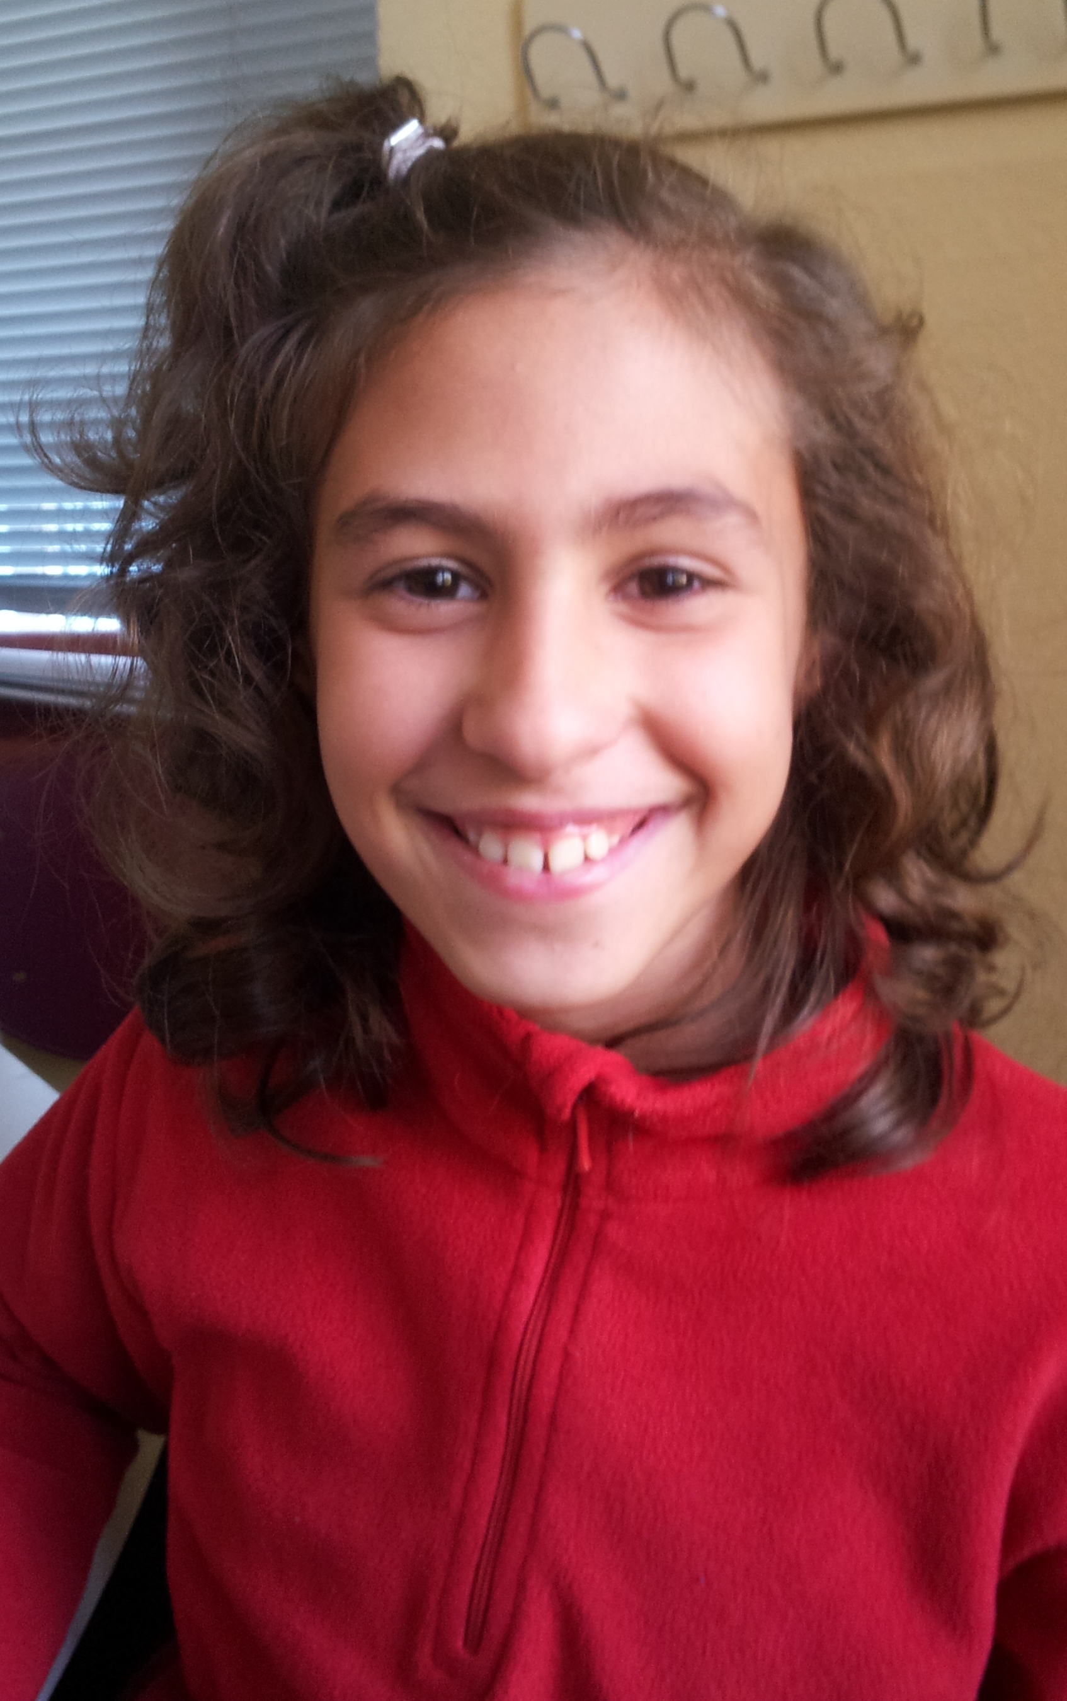
Good morning!

My name is Vanesa.
I´m 9 years old.
I´m from Spain.
I live in Socuéllamos.
I walk to school.
Today is Tuesday.
My school ´ s name is Gerardo Martinez.
There are twenty-two studets in my classroom.
My English teacher is Carlos.
My best friend is Pilar.

