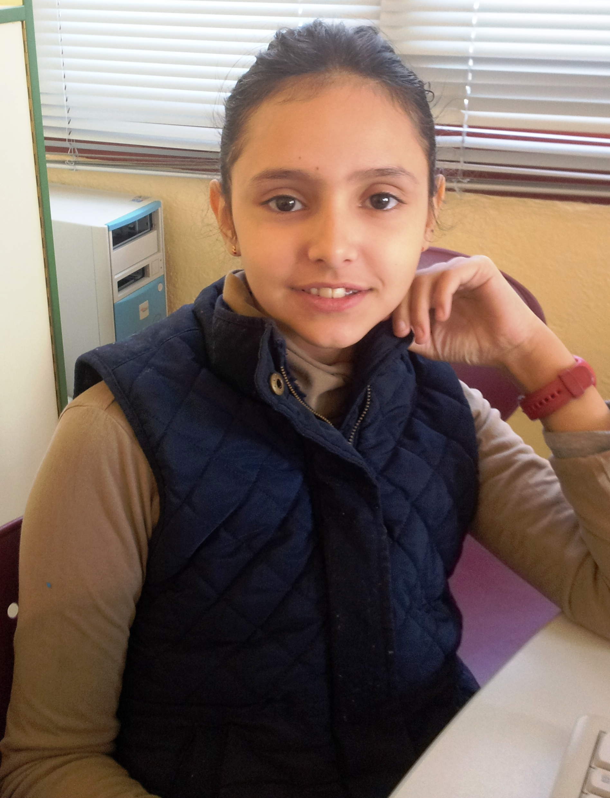
Hello !

My name is Tania
I´m 10 years old .
I´m from Spain.
I live in Socuéllamos
I go to school by car .
Today is Tuesday .
My school ´ s name is Gerardo Martínez.
There are twenty- two students in my classroom .
My English teacher is Carlos.
My best friend is Minerva .

