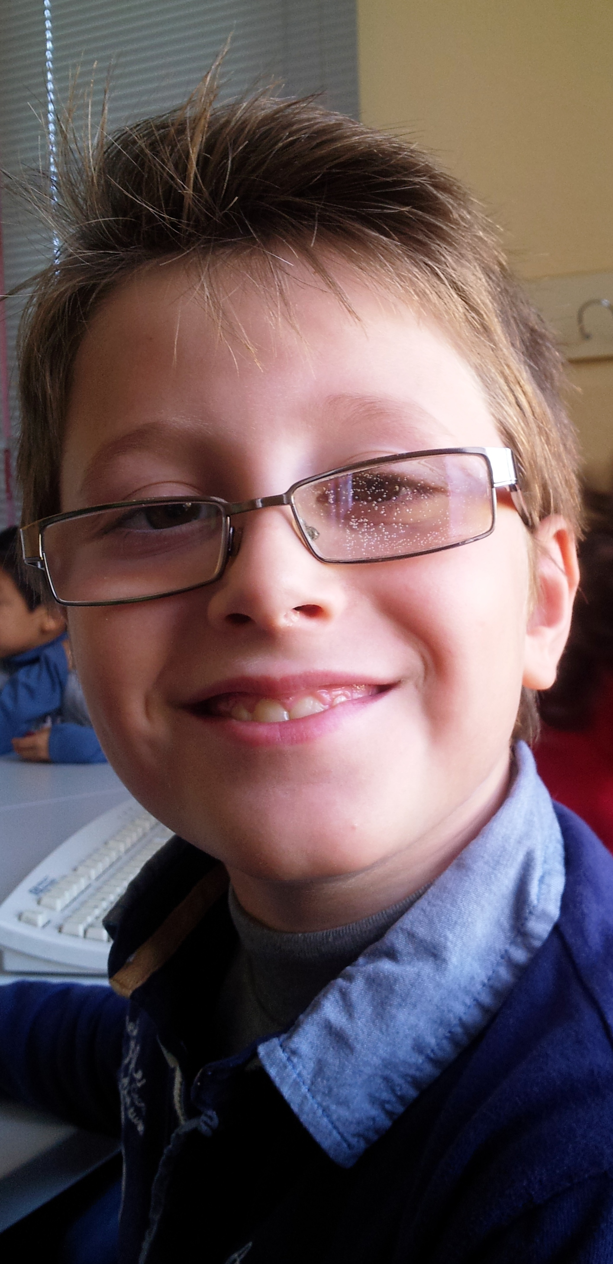

Hello!

My name is Santiago.
I´m 9 years old.
I´m from Spain.
I live in Socuèllamos.
I walk to school.
Today is Tuesday.
My school ´s name is Gerardo Martinez.
There are twenty-two students in my classroom.
My English teacher is Carlos.
My best friend is Jaime.

