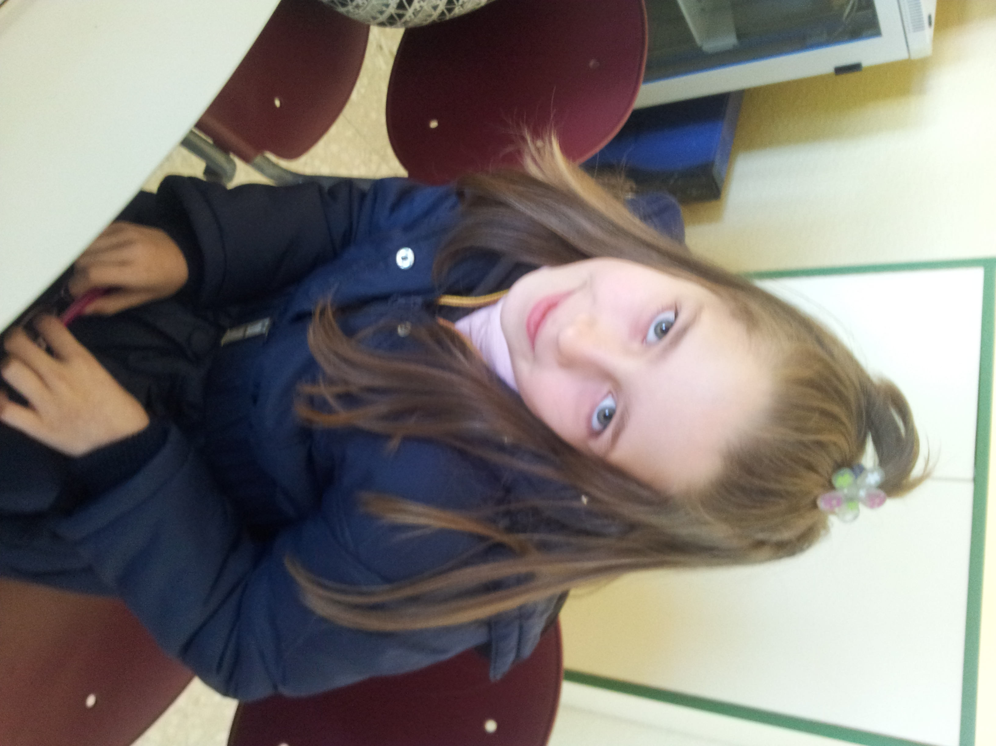
Hello!

My name is Rocio.
I´m 9 years old .
I´m from Spain.
I live in Socuèllamos.
I walk to school.
Today is Friday.
My school´s name is Gerardo Martinez.
There are twenty-four students in my classroom.
My English teacher is Carlos.
My best friend is Maria.

