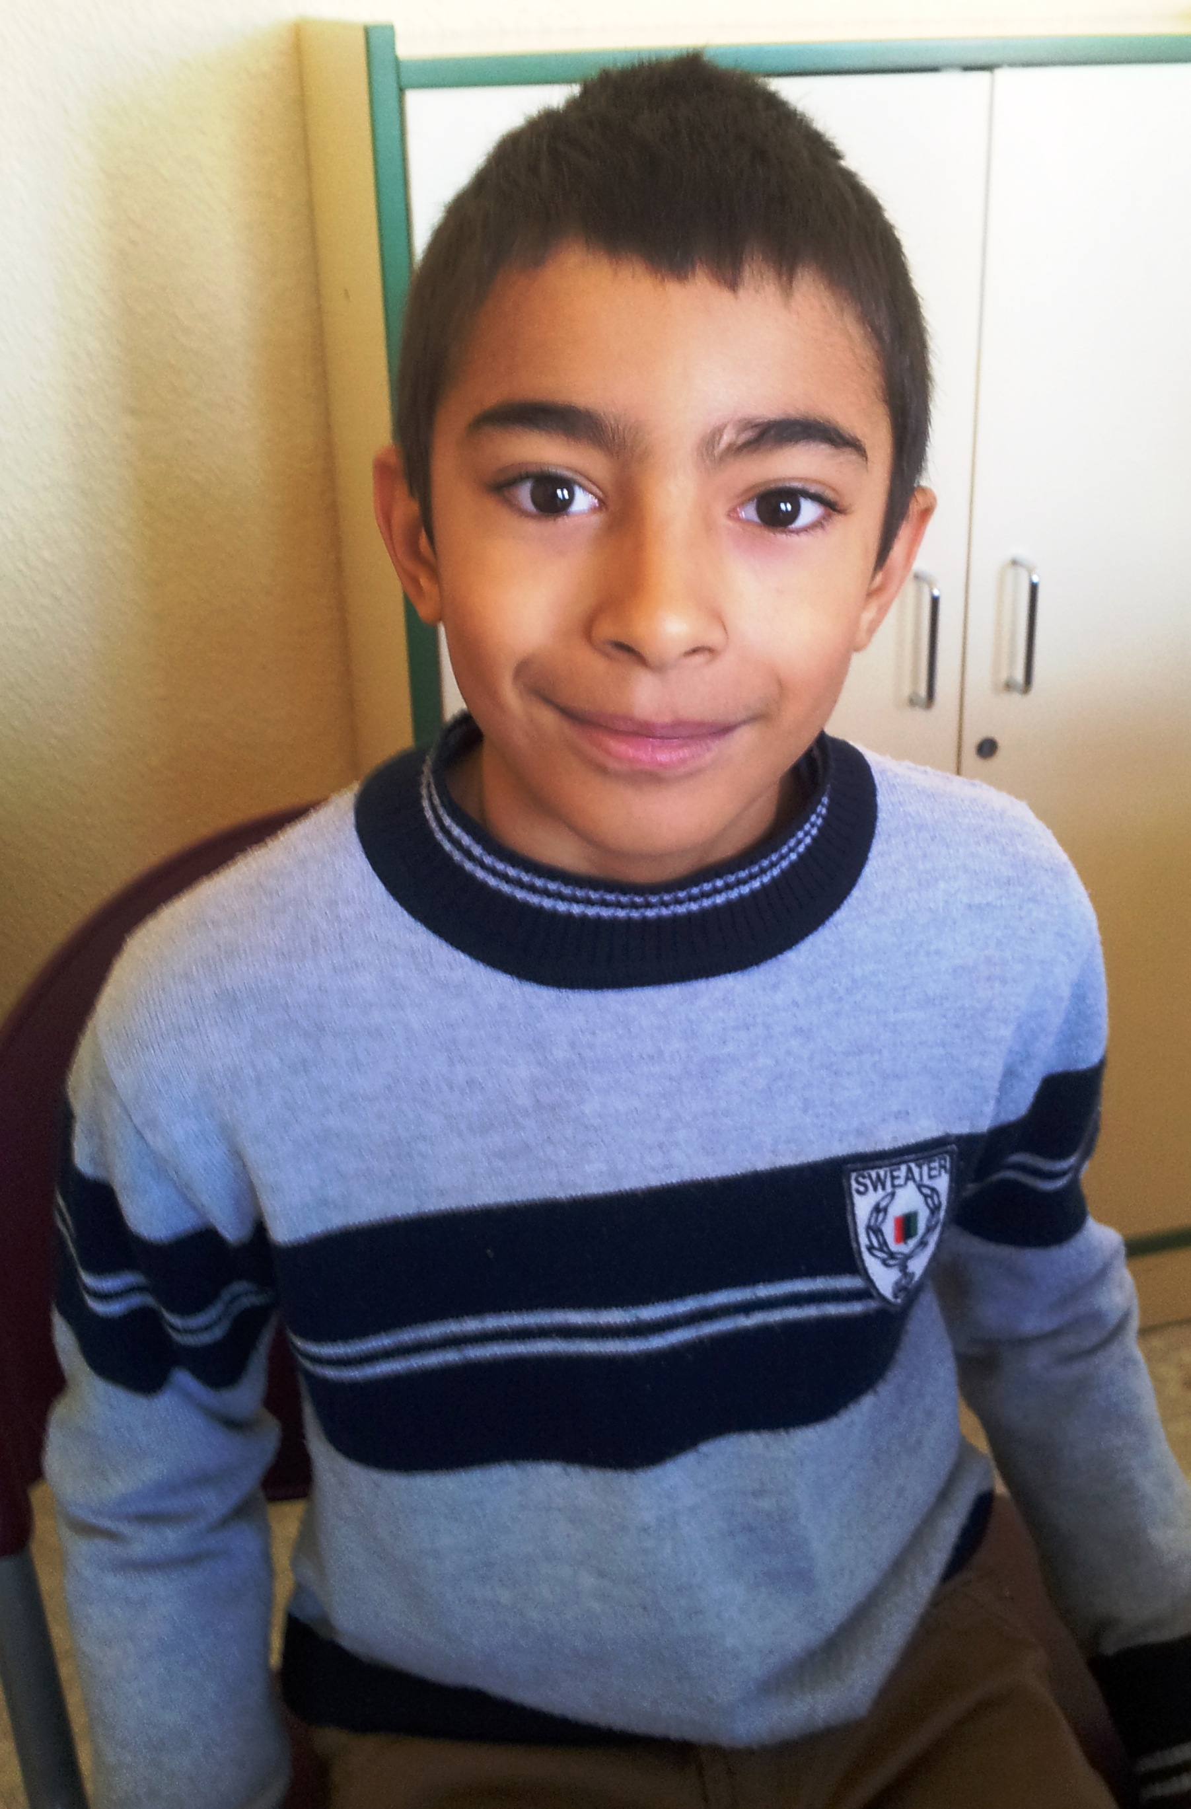
Hello

My name is Roberto .
I´m 9 years old .
I´m from Spain.
I live in Socuéllamos.
I walk to school.
Today is Tuesday.
My school´s name is Gerardo Martinez.
There are twenty-two students in my classroom.
My English classteacher is Carlos.
My best friend is Cristina.

