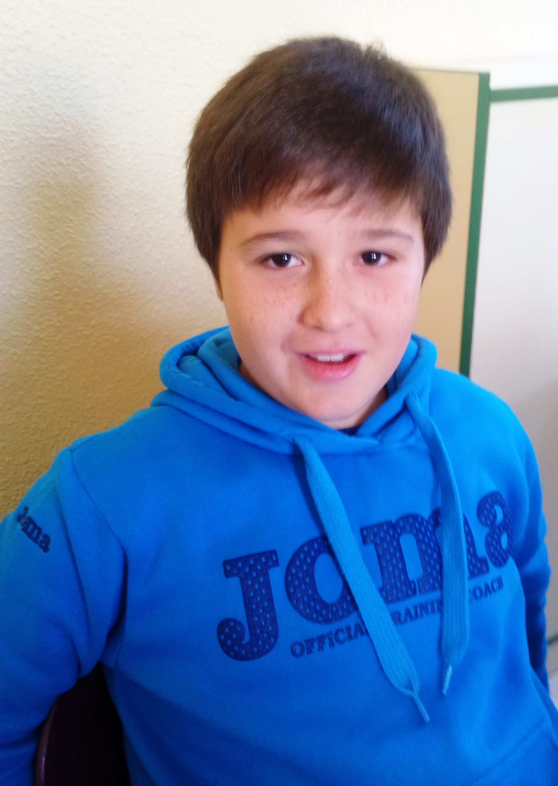
Hello!

My name is Roberto.
I´m 10 years old.
I´m from Spain.
I live in Socuéllamos.
I walk to school.
Today is Tuesday.
My school ´s name is Gerardo Martínez.
There are twenty- two students in my classroom.
My English teacher is Carlos.
My best friend is Manuel.

