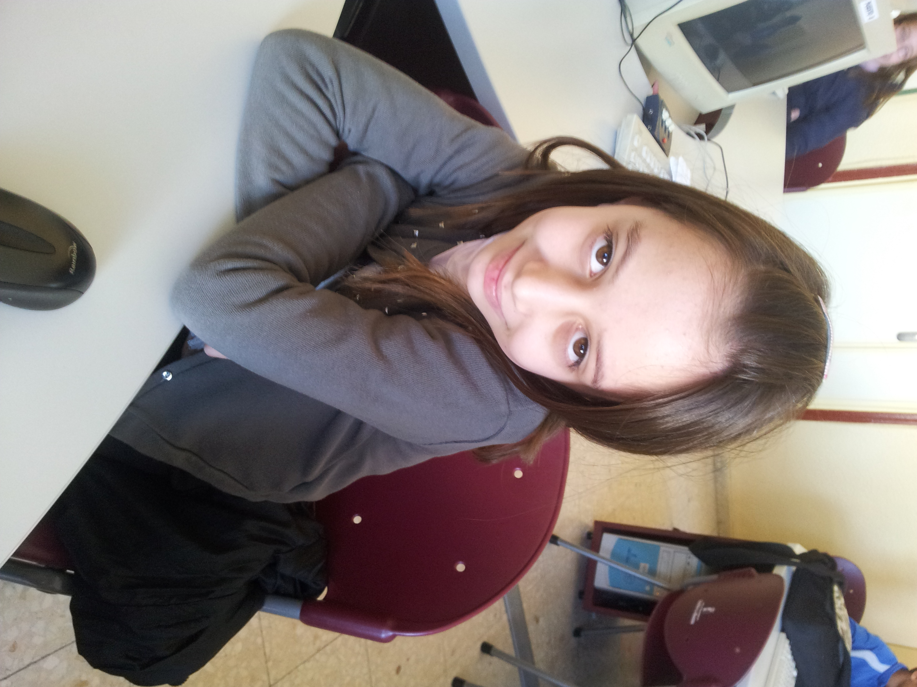
Hello!!!

My name is Nerea Cano.
I´m 9 years old.
I´m from Madrid.
I live in Socuèllamos.
I go to school by car.
Today is Friday.
My school´s name is Gerardo Martinez.
There are twenty-four students in my classroom.
My English teacher is Carlos Garcia.
My best friend is Lucia.

