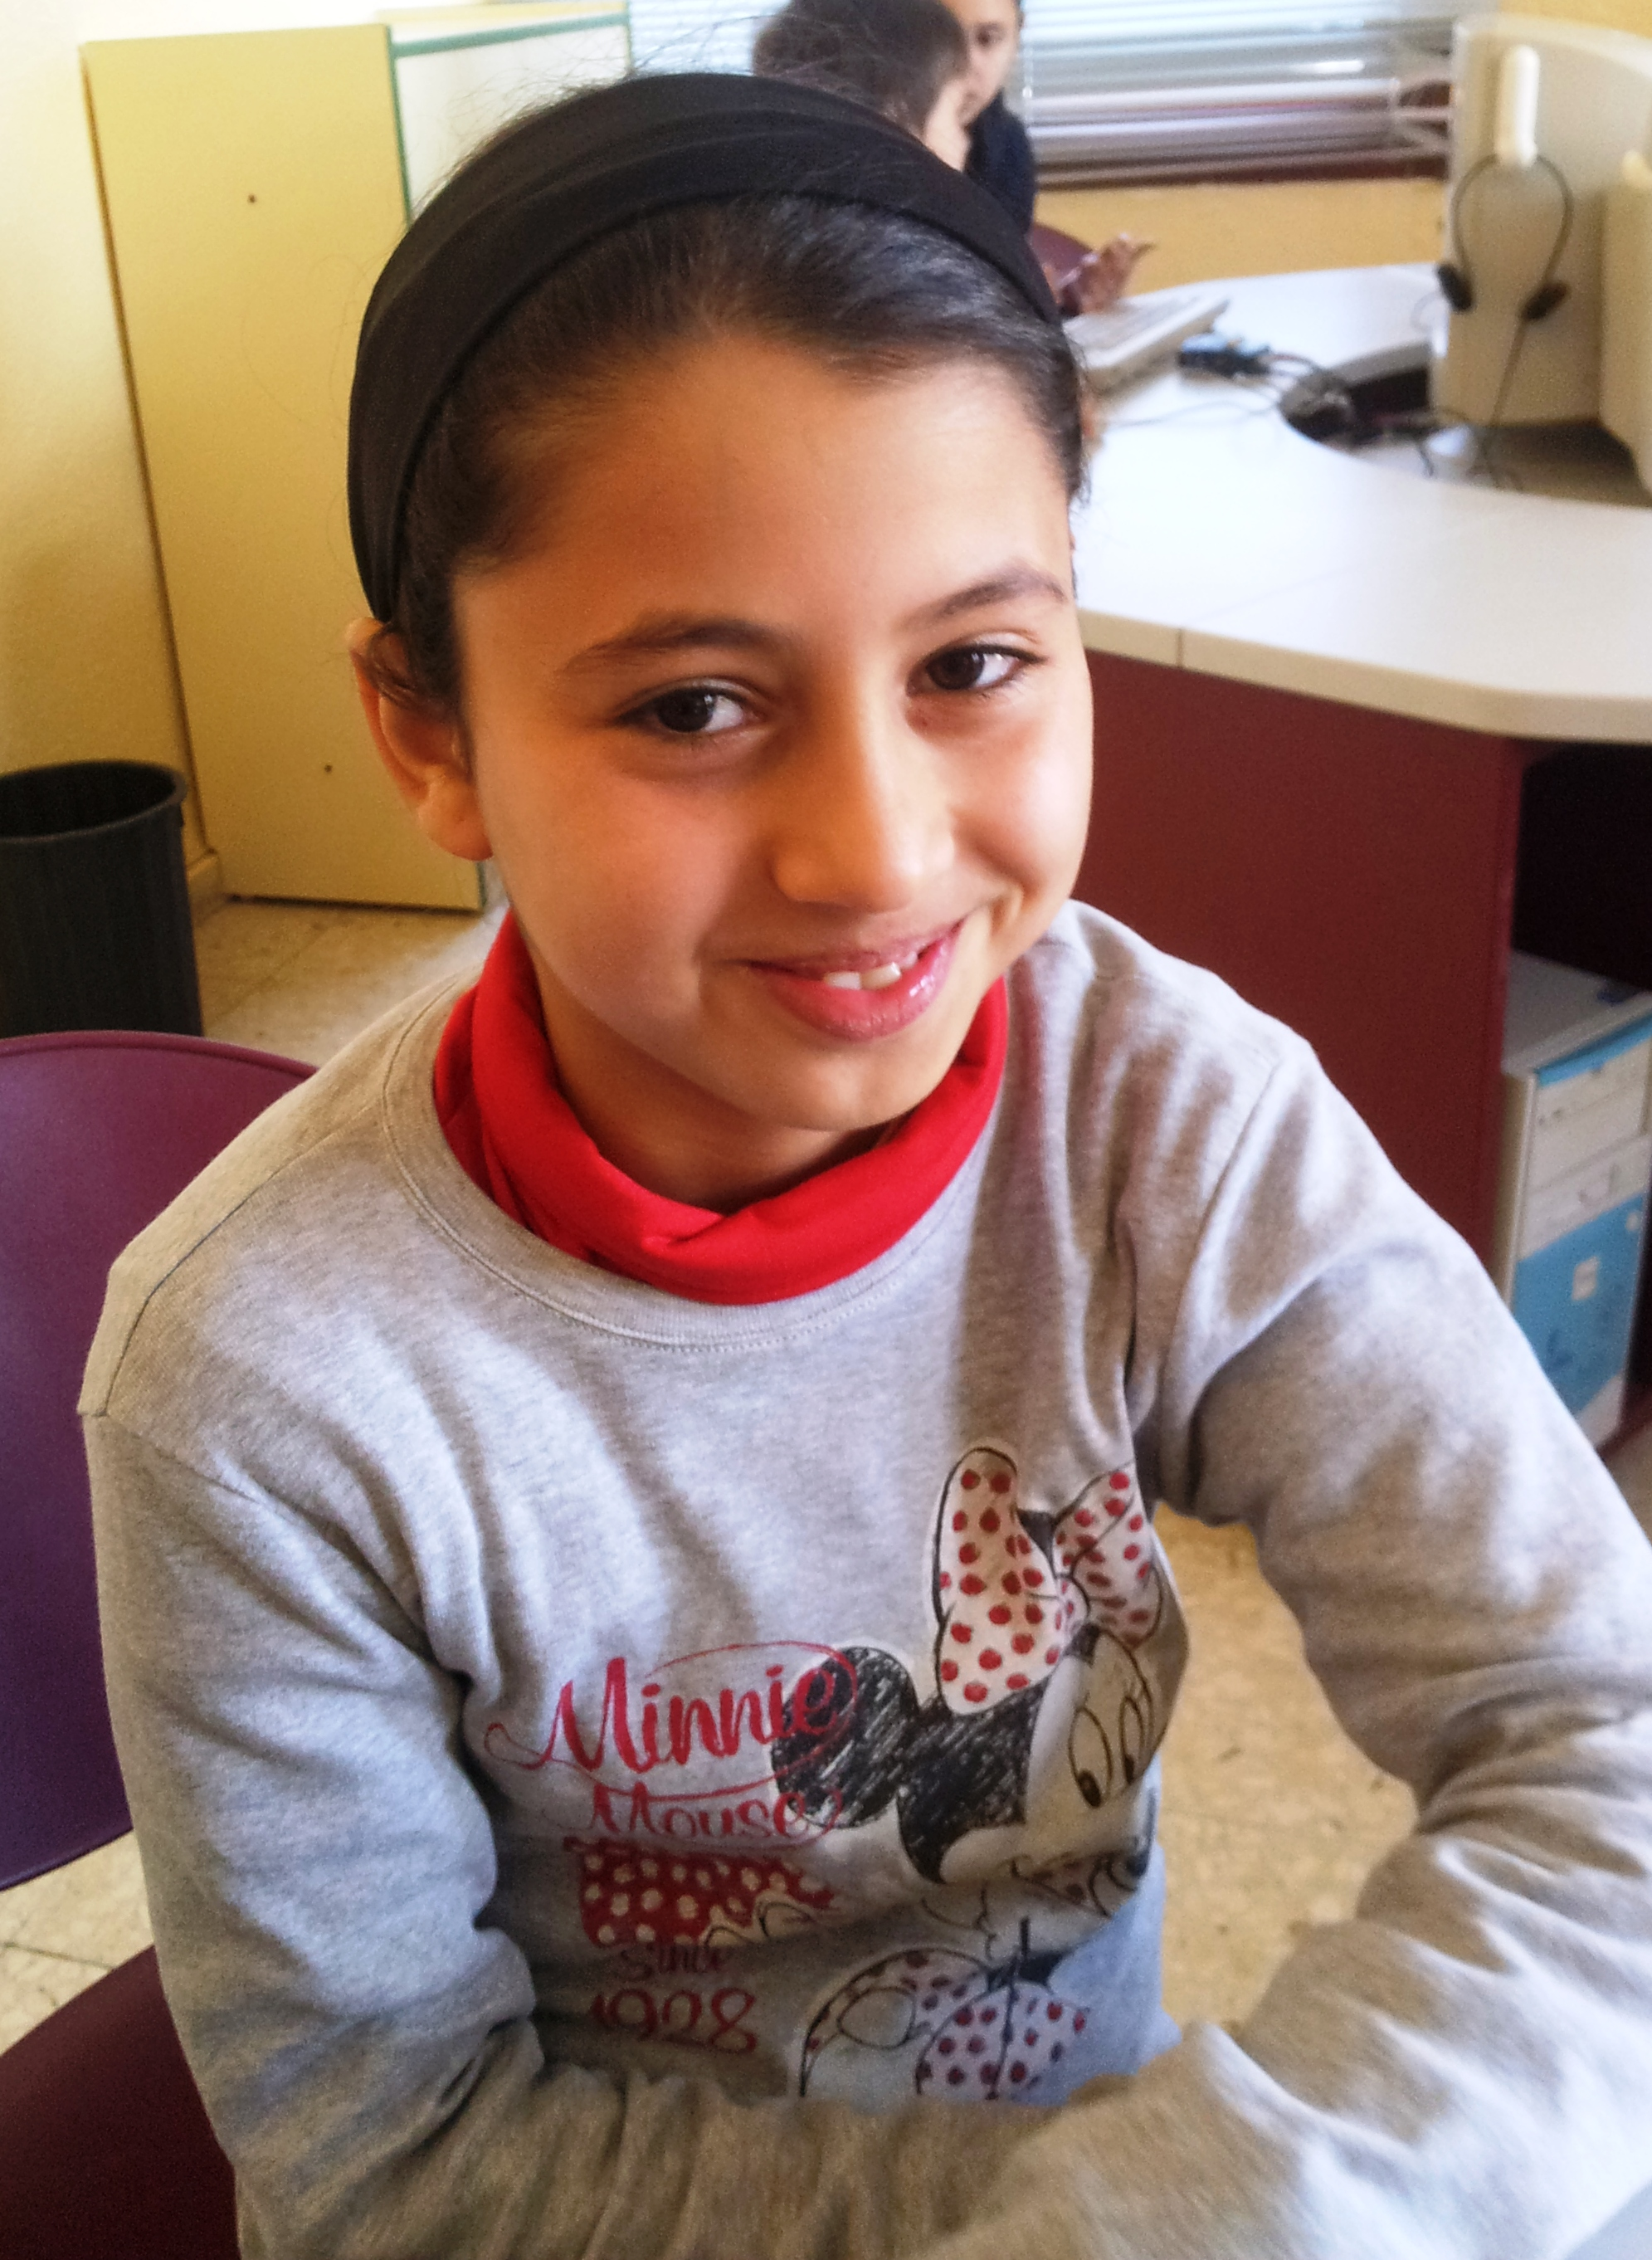
Hello!

My name is Maryam.
I´m 9 years old.
I´m from Morocco.
I live in Socuéllamos.
I walk to school.
Today is Tuesday.
My school´s name is Gerardo Martínez.
There are twenty-two students in my classroom.
My English teacher is Carlos.
My best friend is Anabel.

