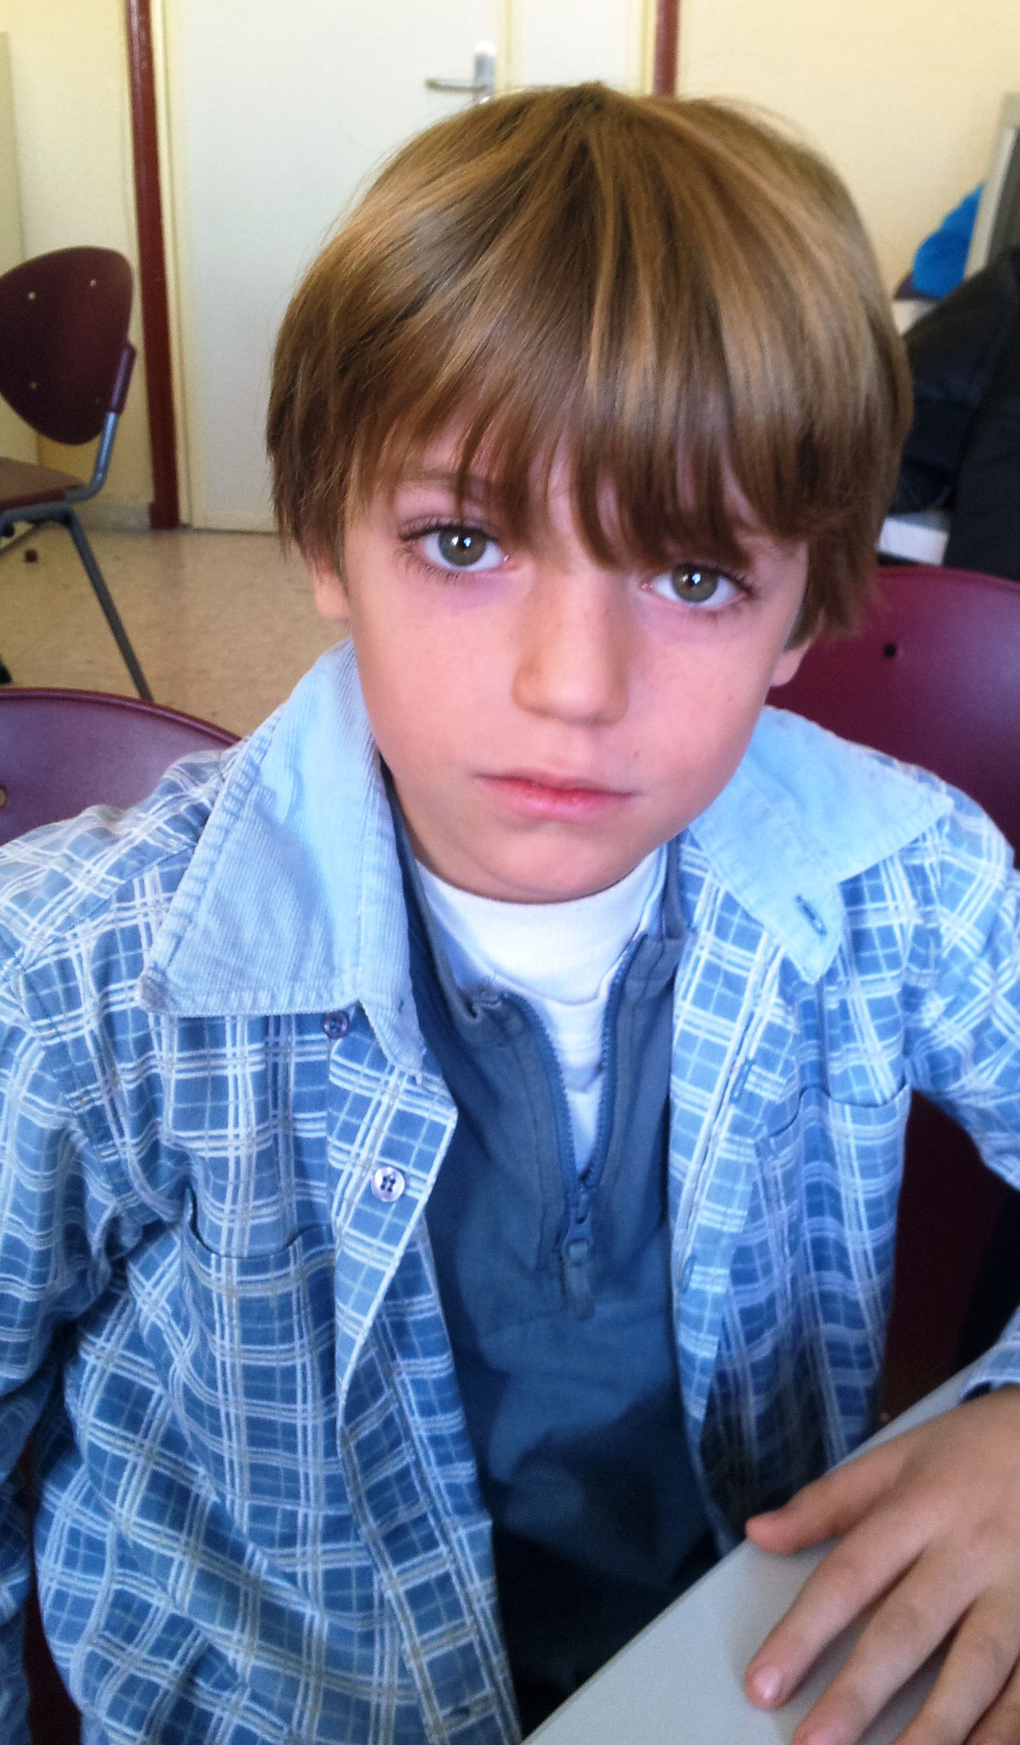
HELLO!

My name is Luis.
I´m 9 years old.
I´m from Spain.
I live in socuéllamos.
I walk to school.
Today is Tuesday.
My school´s name is Gerardo Martínez.
There are twenty-two students in my classroom.
My english teacher is Carlos.
My best friend is álvaro HENALES.

