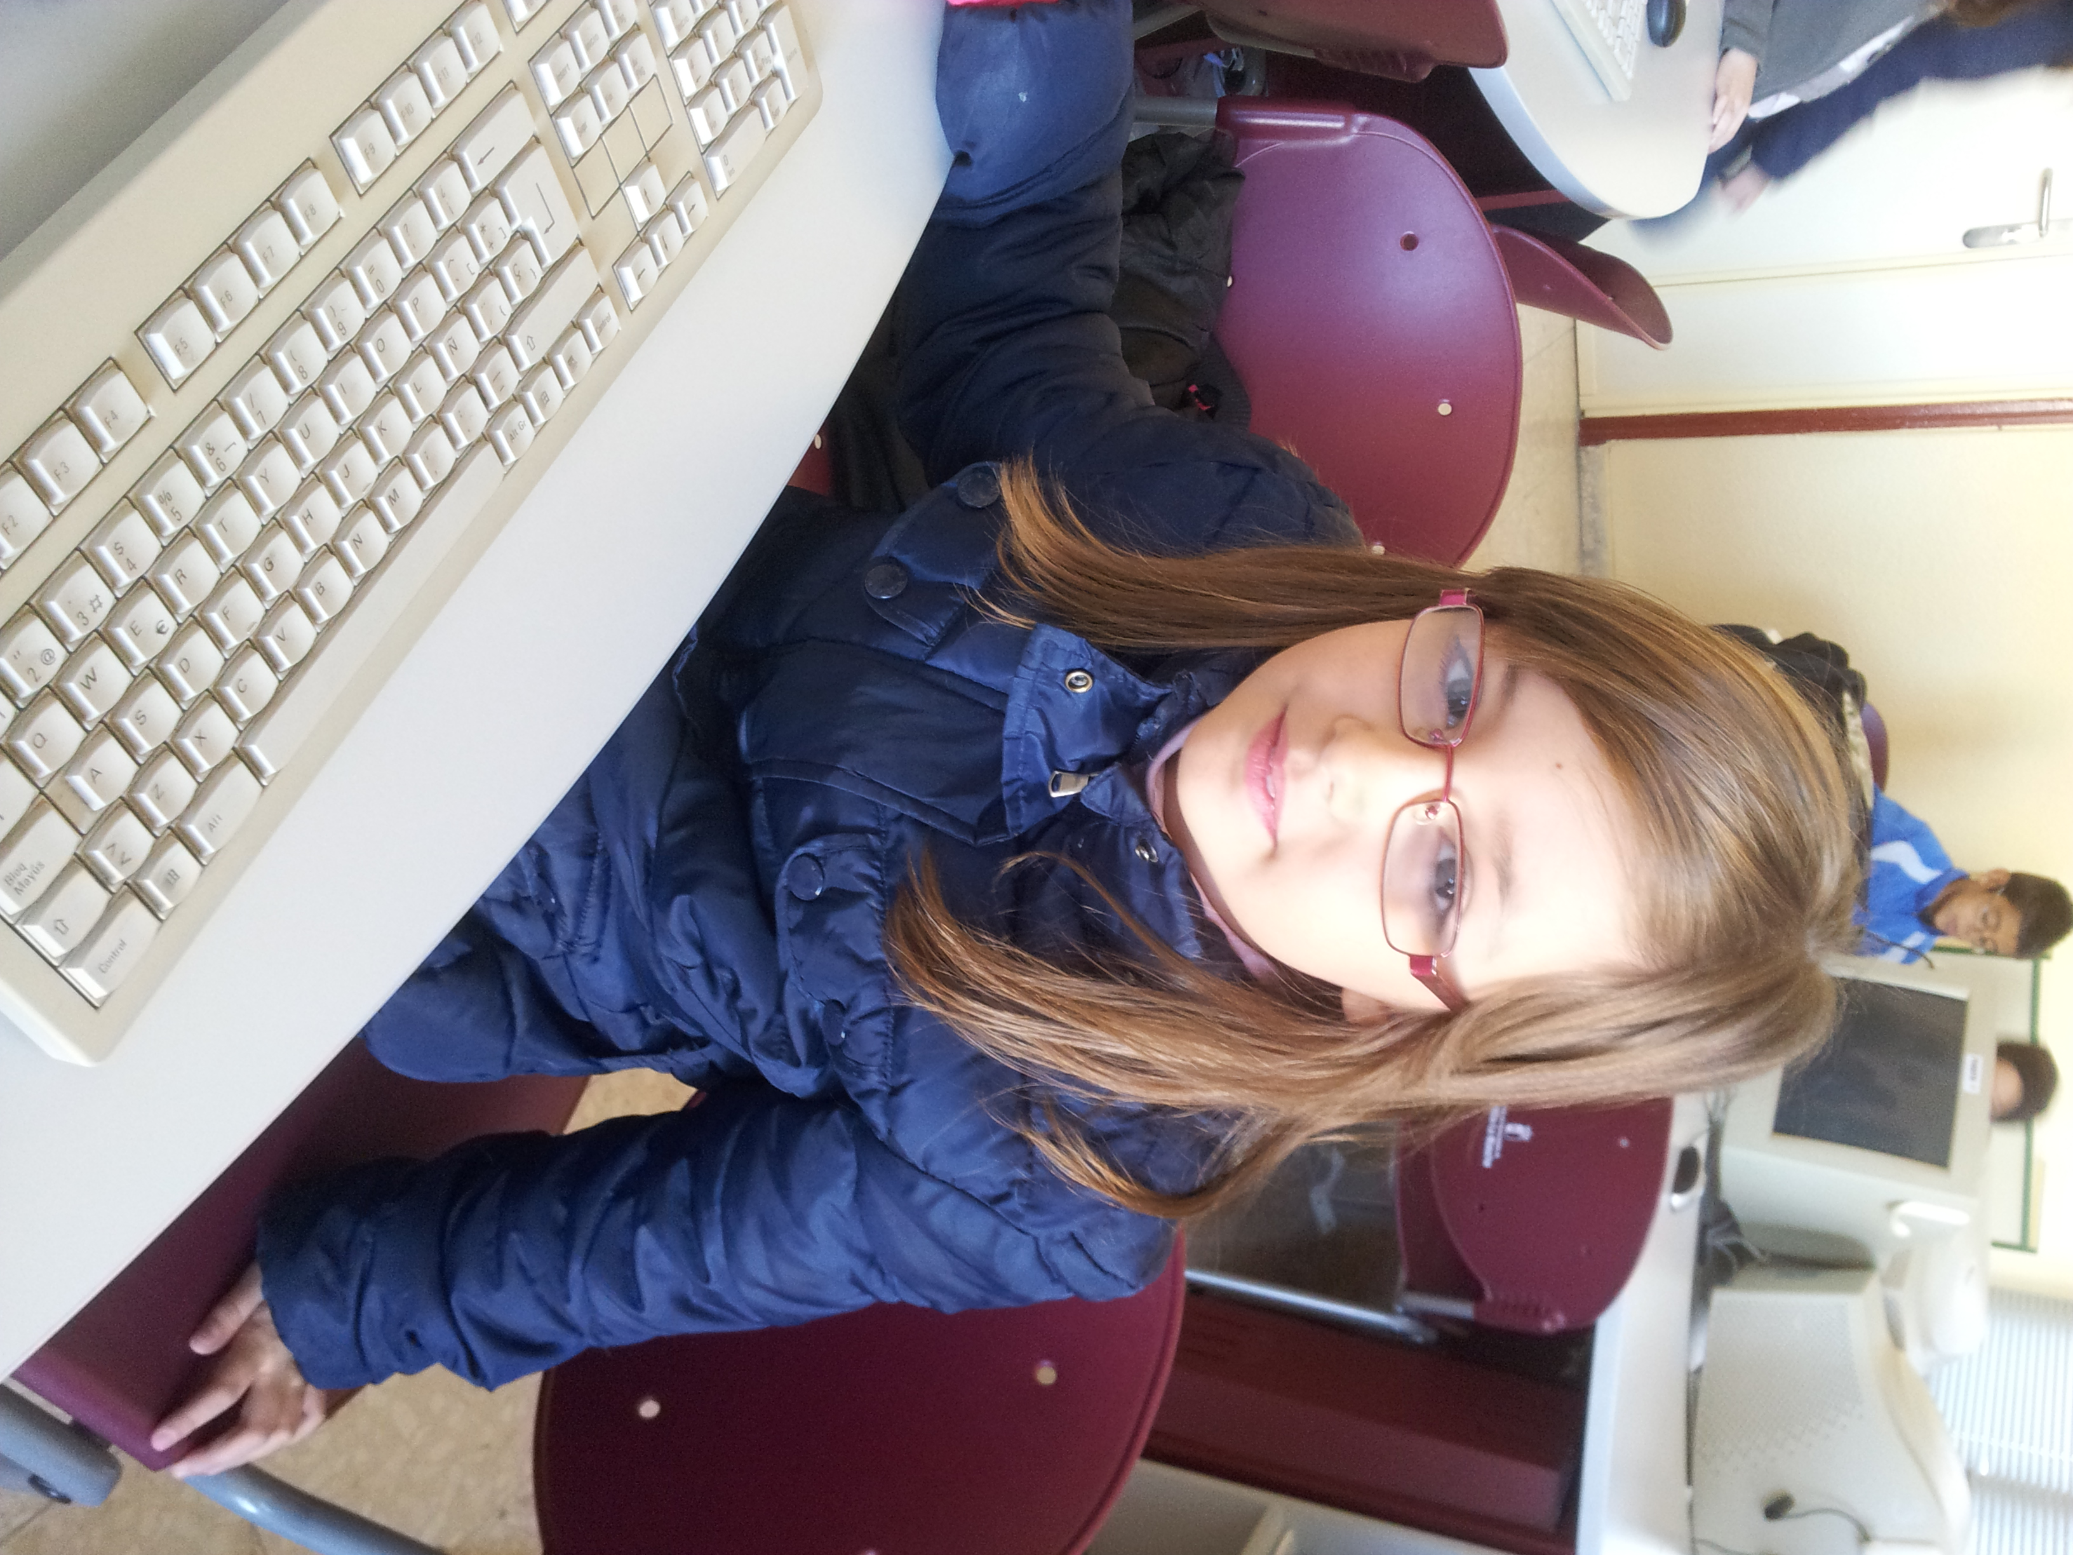
Hello!!

My name is Lucia.
I´m 9 years old.
I´m from Spain.
I live in Socuèllamos.
I go to school by car.
Today is Friday.
My school´s name is Gerardo Martinez.
There are twenty four students in my classroom.
My english teacher is Carlos.
My best friend is Nerea.

