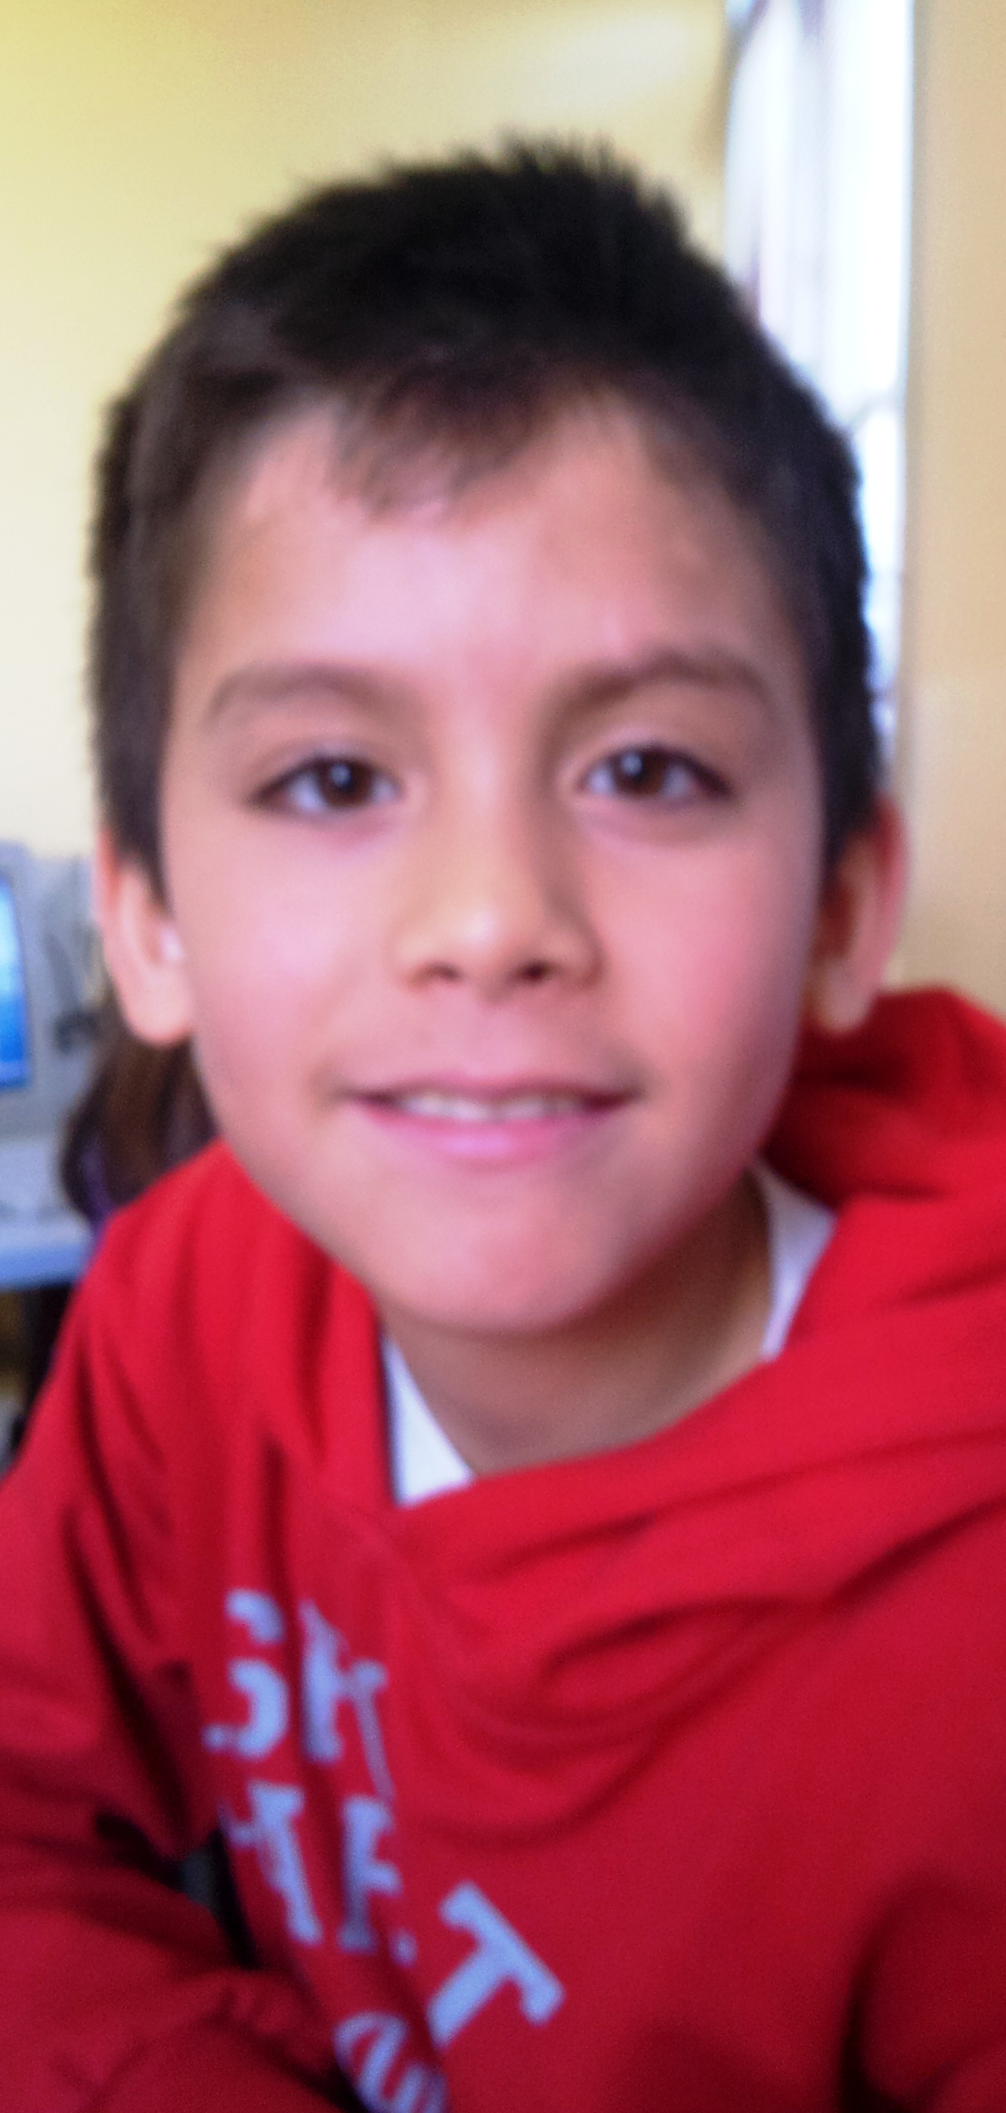
Hello!

My name is Kevin.
I´m 10 years old.
I´m from Spain.
I live in Socuéllamos.
I walk to school.

