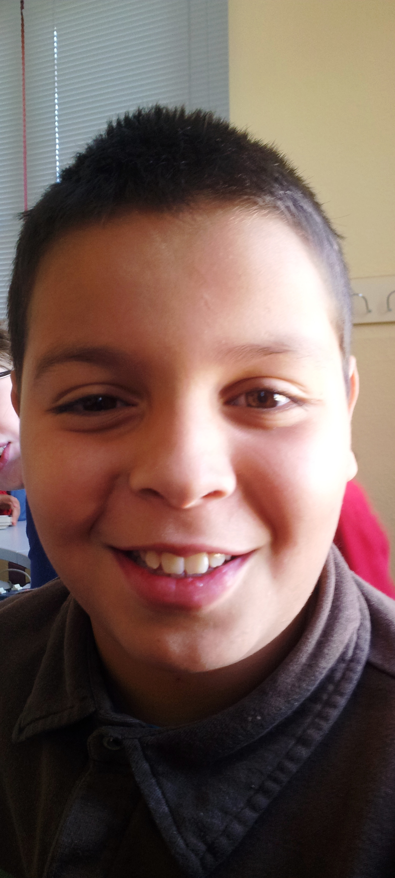

Hello!

My name is Javier.
I´m 9 years old.
I´m from Morocco.
I live in Socuéllamos.
I walk to school.
Today is Tuesday.
My school ´s name is Gerardo Martìnez.
There are twenty-two students in my classroom.
My English teacher is Carlos.
My best friend is Luis.

