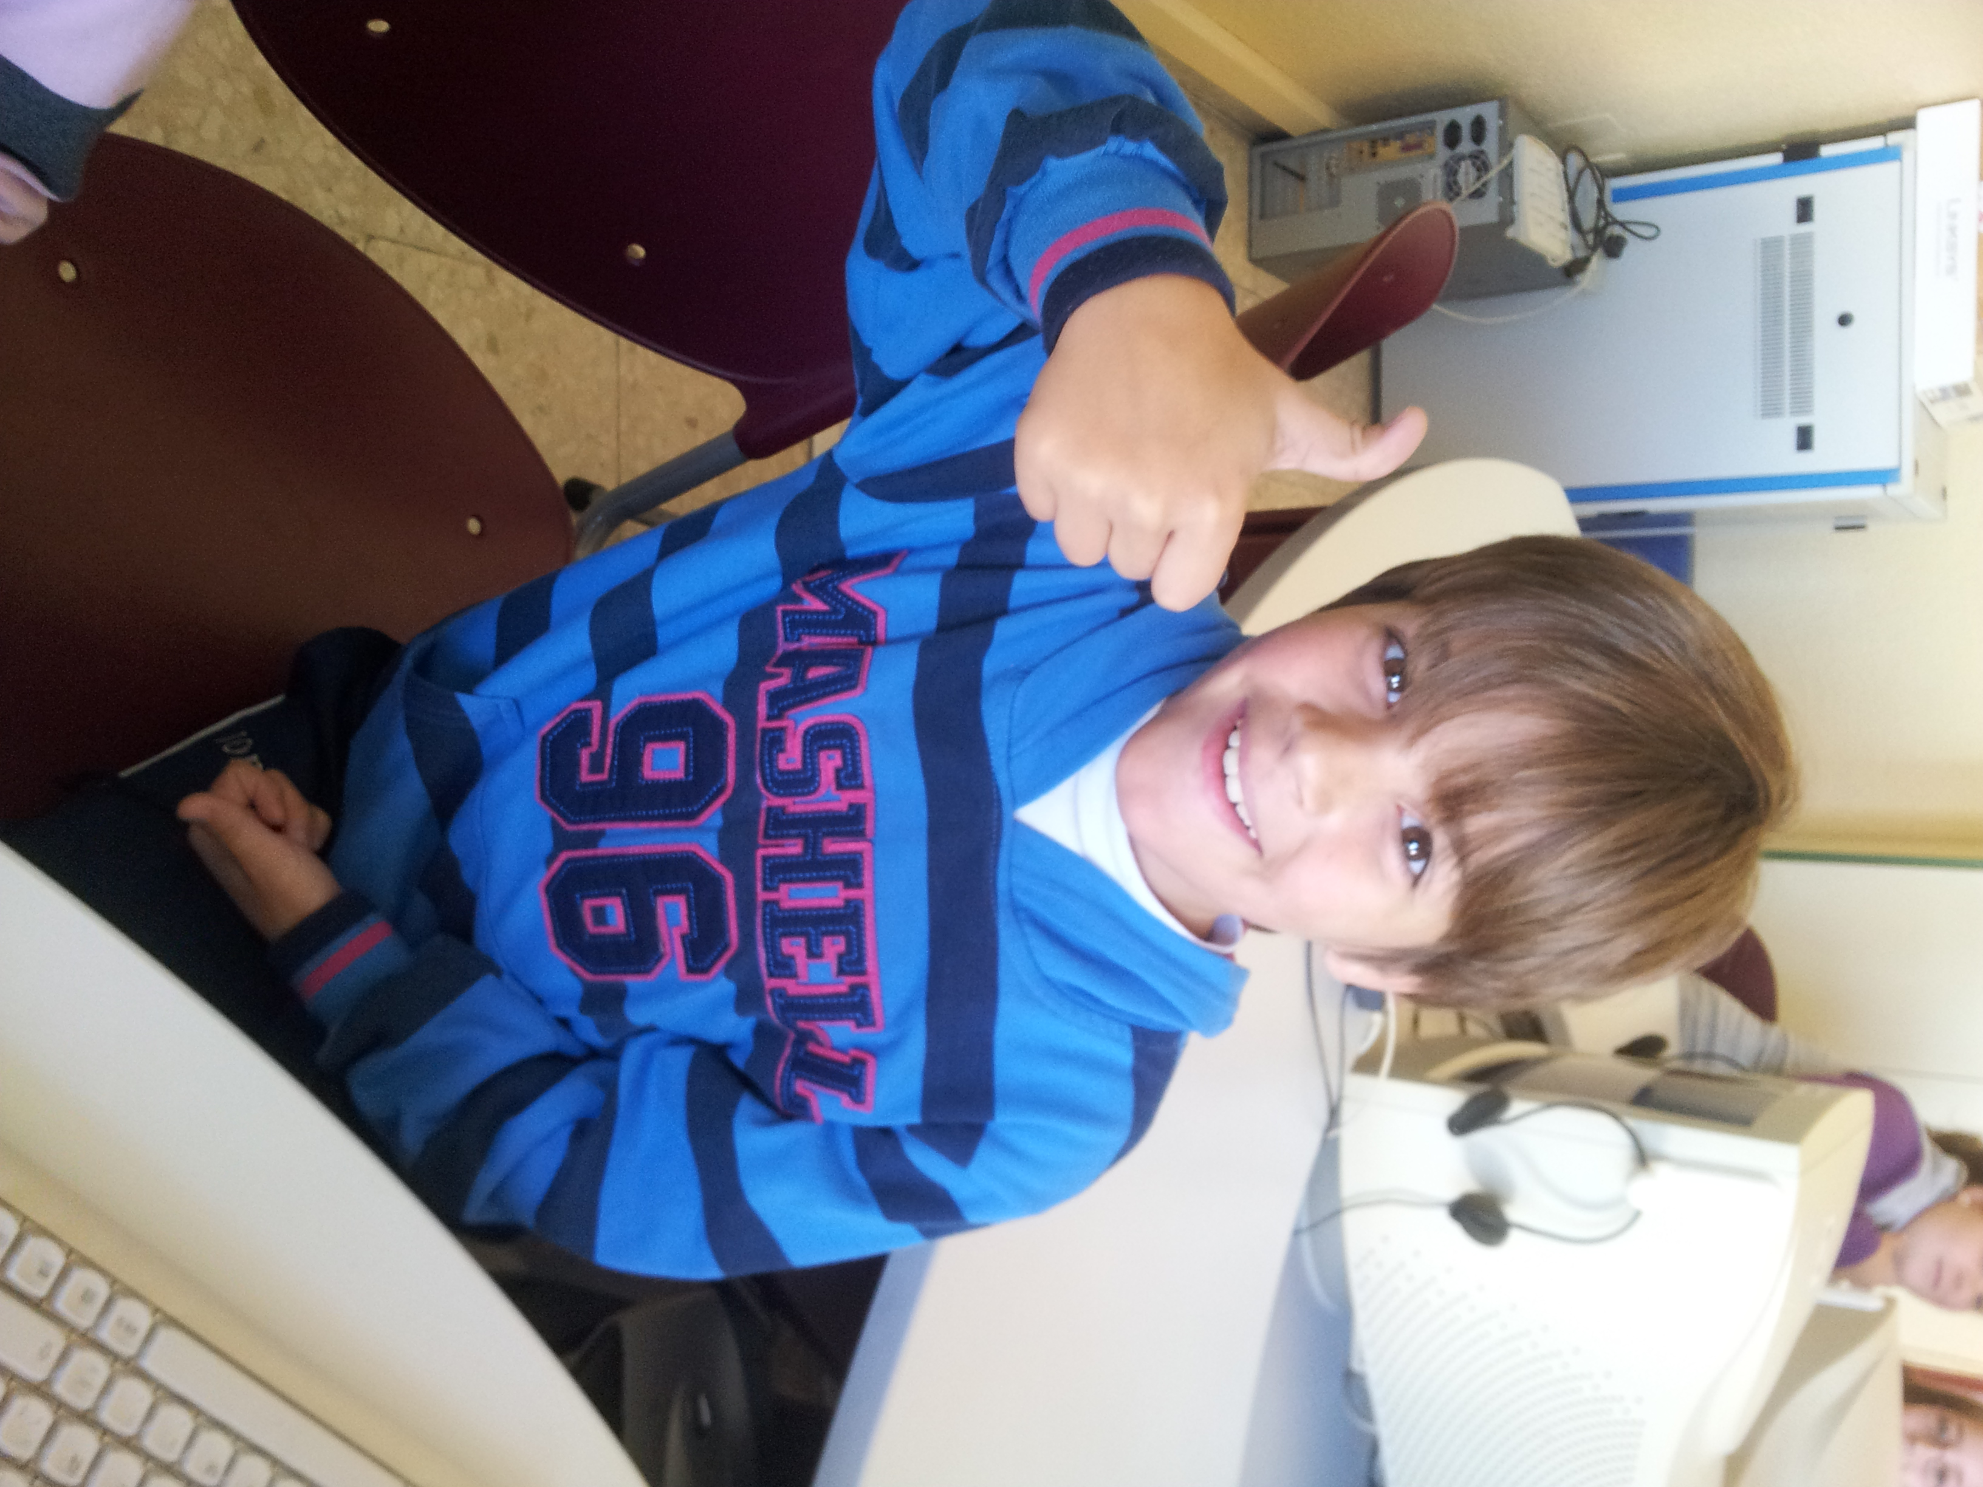
HELLO!!!!

My name is DANIEL.
I´M 9 YEARS OLD.
I´M FROM Spain.
I live in Socuéllamos.
I go to school by car.
Today is Friday.
My school´s name is Gerardo Martinez.
There are twenty-four students in my classroom.
My English teacher is Carlos.
My best friend is Samuel.

