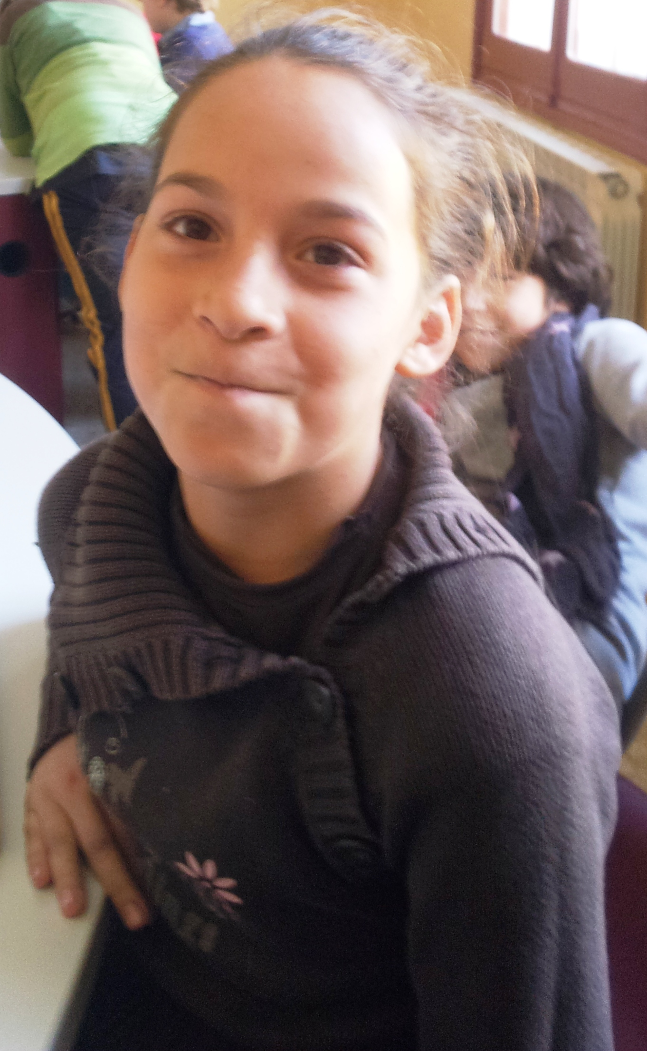
Hello!

I´m 10 years old.
My name is Coral.
I´m from Spain.
I live in Socuéllamos.
I walk to school.
Today is Tuesday.
My school´s name is Gerardo Martínez.
There are twenty-two students in my classroom.
My English teacher is Carlos.
My best friend is Vanesa.

