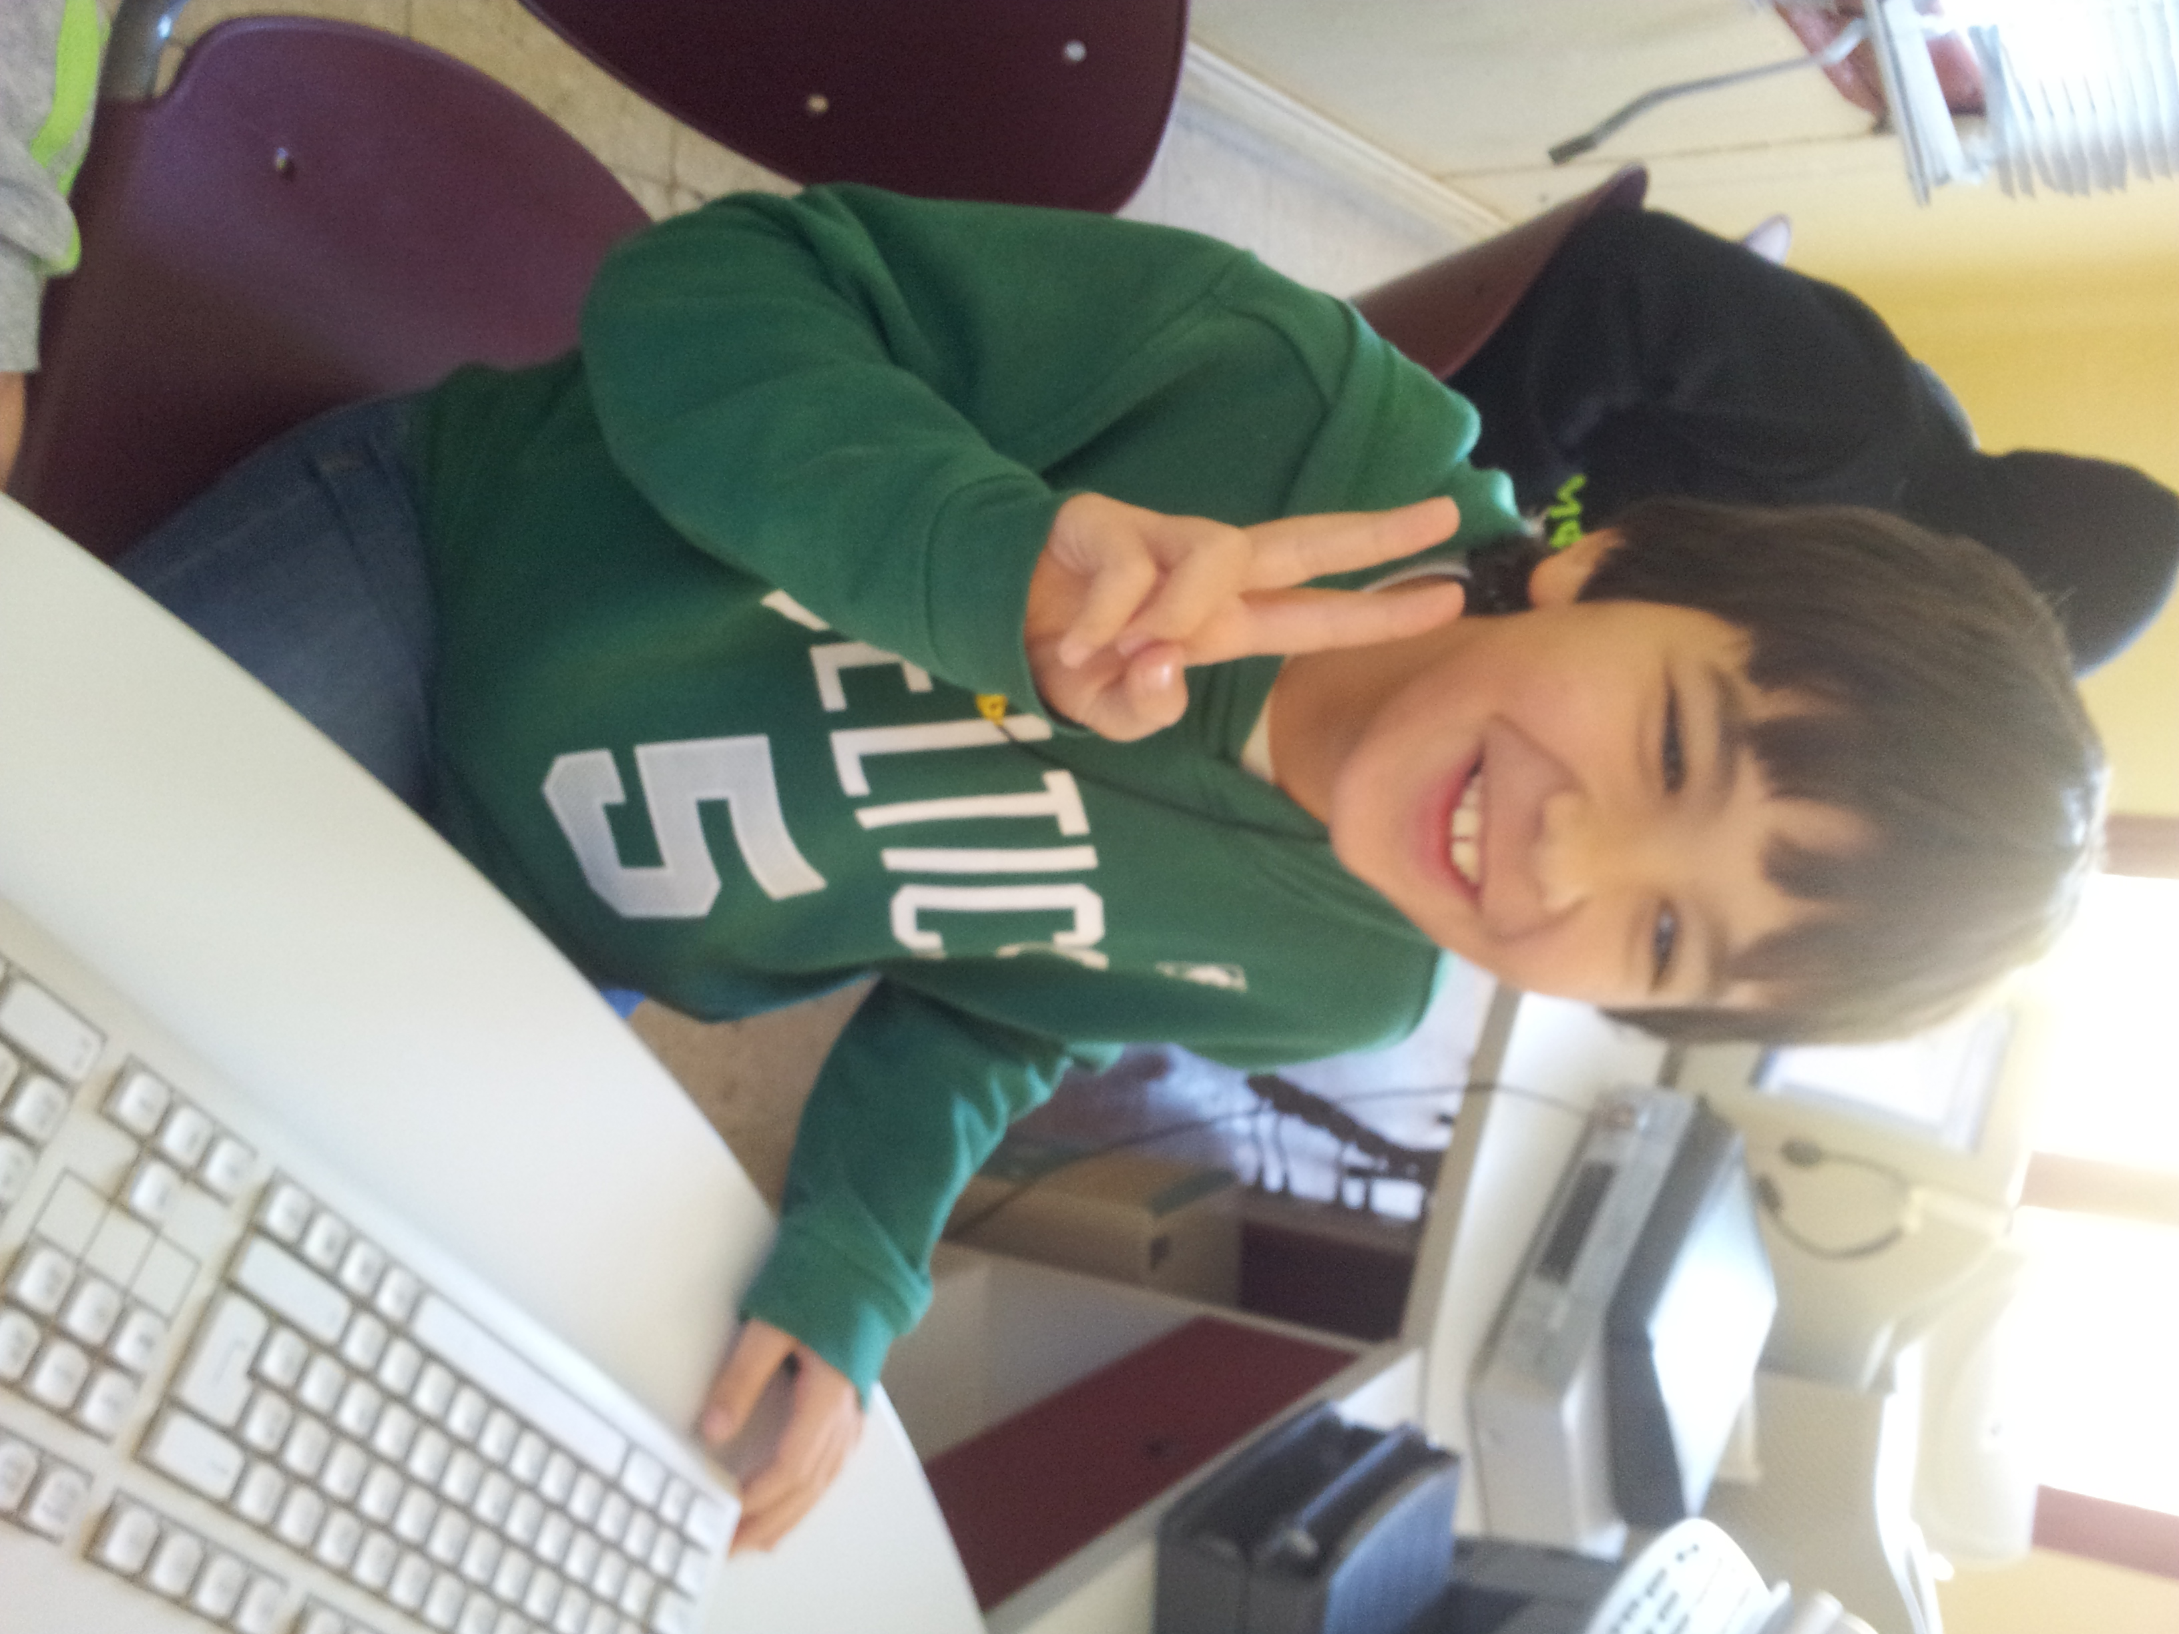
Hello

My name is alonso.
I´m 9 years old.
I´m from spain .
I live in socuellamos.
I go to school By car.
TODAy IS FRIDAY.
MY SCHOOL´s name IS GERARDO MARTINEZ .
There are twenty-four students in my classroom.
My english teacher is carlos.
My best friend is alvaro .

