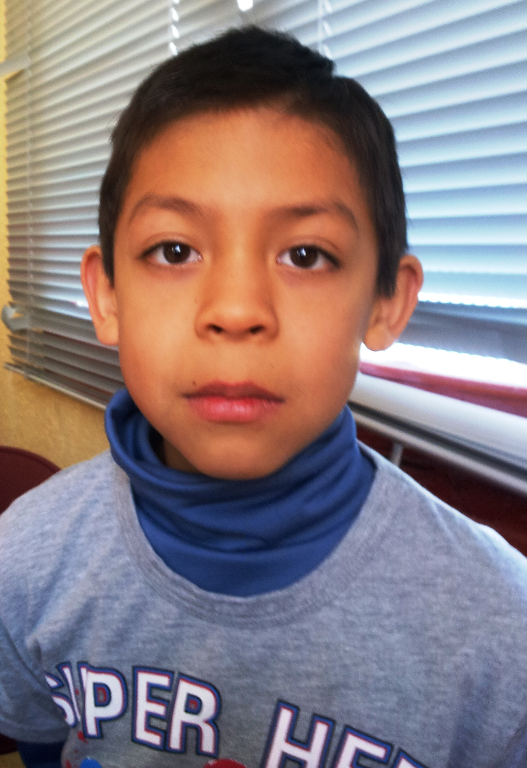
Hello!

My name is Alex.

I´m 9 years old.

I´m from Ecuador .

I live in Socuéllamos.

I walk to school.

Today is Tuesday.

My school´s name is Gerardo Martinez .

There are twenty-two students in my classroom.

My English teacher is Carlos.

My best friend is Alvaro.

