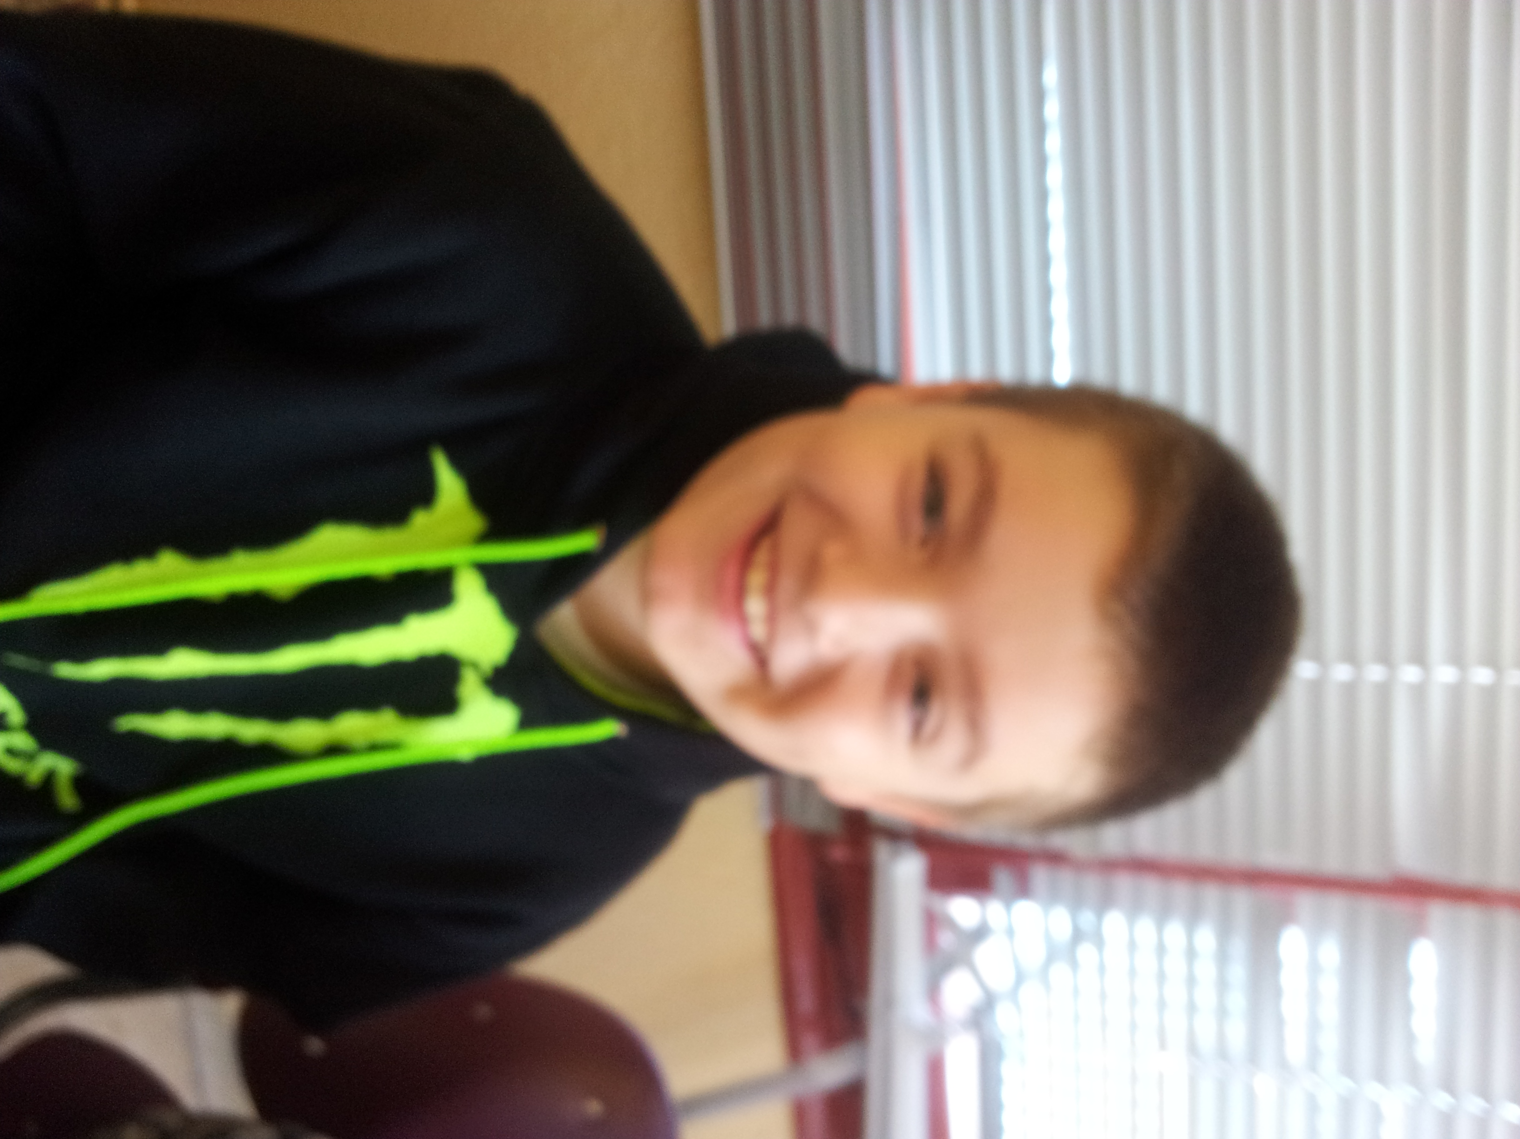
HELLO

MY NAME IS ADRIAN.
I´M 10 YEARS OLD.
I´M FROM ROMANIA.
I LIVE IN SOCUÈLLAMOS.
I GO TO SCHOOL BY CAR.
TODAY IS FRIDAY.
MY SCHOOL´S NAME IS GERARDO MARTINEZ.
THERE ARE TWENTY FOUR STUDENTS IN MY CLASSROOM.
MY ENGLISH TEACHER IS CARLOS GARCIA.
MY BEST FRIEND IS SERGIO

