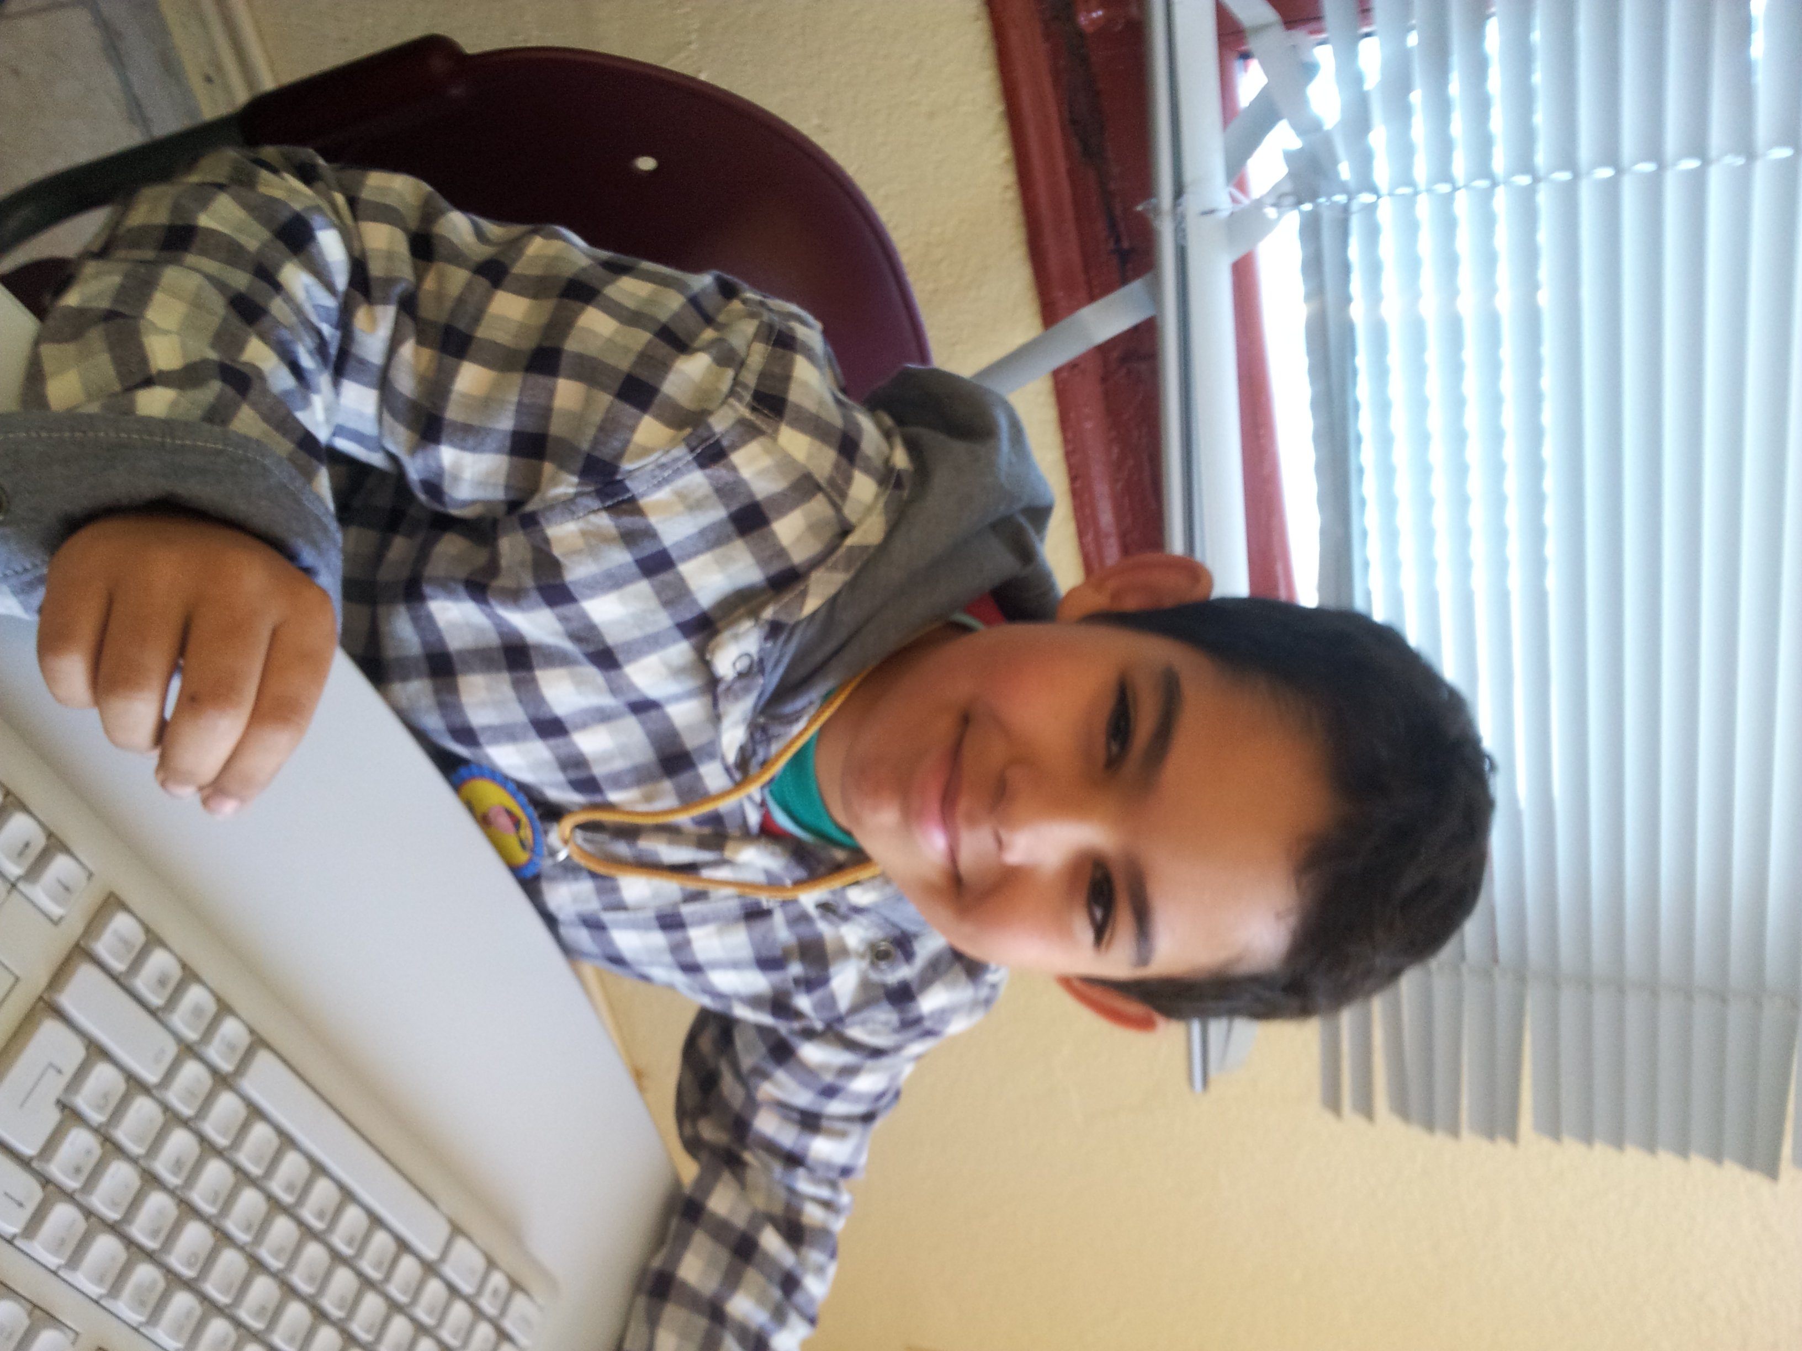
Hello

My name is adel.
I´M 9YEARS OLD.
I´M FROM MOROCCO.
I LIVE IN SOCUELLAMOS.
I WALK TO SCHOOL.
TODAY IS FRIDAY.
MY SCHOOL´S NAME IS GERARDO MARTINEZ.
THERE ARE TWENTY-FOUR STUDENTS In MY CLASSROOM.
MY ENGLISH TEACHER IS CARLOS.
MY BEST FRIEND IS JAVIER

